**Course9-Direction follower**

****Learning goals:****

This lesson learns the use of compasses to achieve the orientation of the micro:bit, and the arrows above the micro:bit dot matrix point to the north.

**Code：**

from microbit import *

compass.calibrate()

while True:

needle = ((15 - compass.heading()) // 30) % 12

display.show(Image.ALL_CLOCKS[needle])

In the program, the compass.calibrate() function is first called to perform compass calibration. The calibration process is as shown in Figure 9-1. The small red dot in the center is drawn on the micro:bit dot matrix. After the description, a smiley, will appear on the dot matrix, which indicating calibration is complete

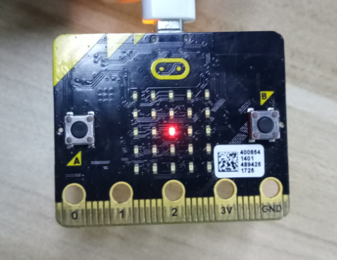

Figure 9-1

**Programming and downloading：**

1. You should open the Mu software, and enter the code in the edit window, , as shown in Figure 9-2.

**Note! All English and symbols should be entered in English, and the last line must be a space.**

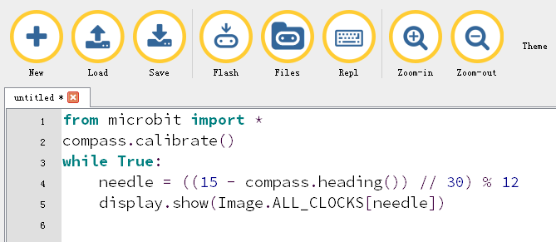

Figure 9-2

2.As shown in Figure 9-3, you need to click the Check button to check if our code has an error. If a line appears with a cursor or an underscore, the program indicating this line is wrong.

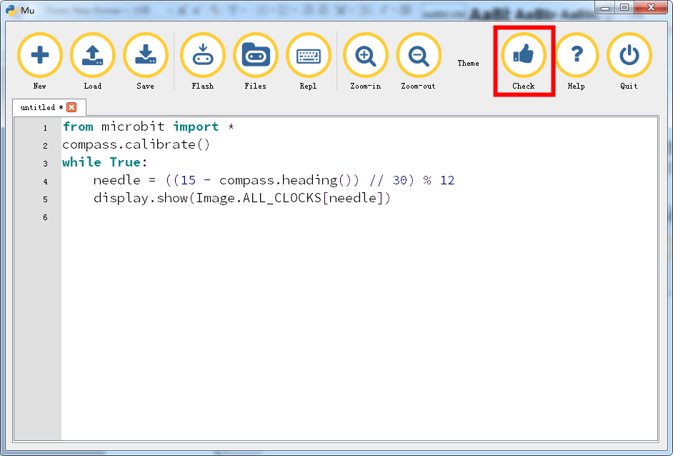

Figure 9-3

3.You need to connect the micro data cable to micro:bit and the computer, then click the Flash button to download the program to micro:bit as shown in Figure 9-4.

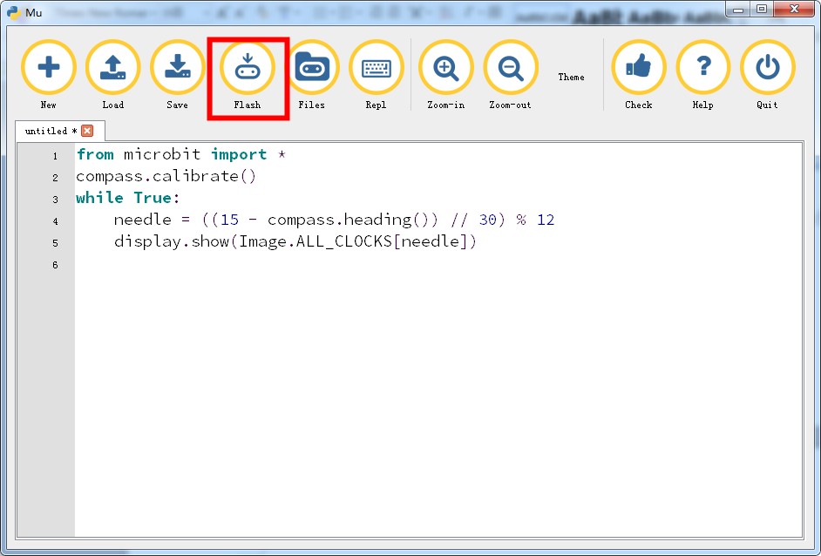

Figure 9-4

4. Experimental phenomena as shown in Figure 9-5 to Figure 9-10, no matter how you turn micro:bit, the pointers on the dot matrix point to the north.

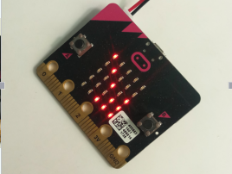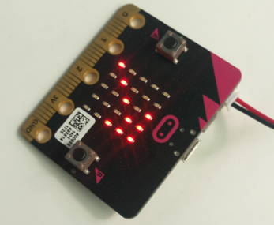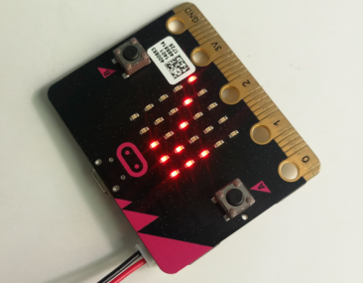

Figure 9-5 Figure 9-6 Figure 9-7

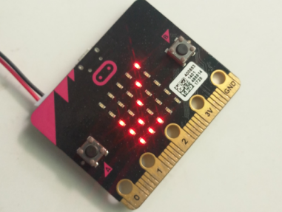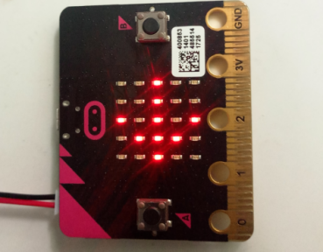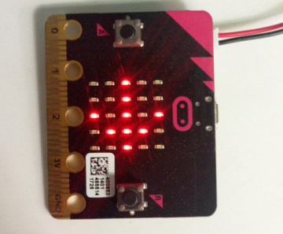

Figure 9-8 Figure 9-9 Figure 9-10